The 1st International Conference on Physics, Photonics and Optical Engineering(ICPPOE2022)
November 11-13, 2022, Kunming, China

- HOME
  - About
ICPPOE2022 aims to provide a forum to bring researchers, academics and practitioners together to exchange ideas and discuss the latest research results on various aspects of physics, photonics, optoelectronics, optical engineering and other related fields. The focus of the conference is to establish an effective platform for institutions and industries to exchange ideas and introduce the work of scientists, engineers, educators and students from all over the world. This conference is a close integration of academia and industry.
Our goal is to build a strong, active and closely connected international research community. We welcome innovative ideas, concepts, services, technologies, research results and business practices.

  - Conference History

  - Publication
Proceeding
All papers, both invited and contributed, will be reviewed by at least 3 experts from the committees. After a careful reviewing process before the final decision and detailed presentation at the conference, all the accepted papers will be submitted to EI, CPCI indexed proceeding from a top publisher.

Journals
Some of the best papers of ICPPOE2022 will have the chances to be recommended to SCI / EI journals for publishing, In such case, the papers must be significantly changed after improvement and expanding - usually, at least 30% changes are requested.

  - Organizers and Sponsors
Organizers

Co-oganizers
Technical and service provider

- COMMITTEE

  - Chairs

Honorary Chair

General Chair

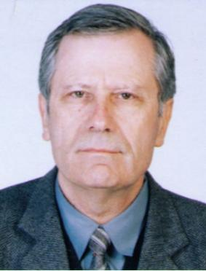
Prof. Dr.Roumen Kountchev
Technical University of Sofia, Bulgaria
Roumen Kountchev, Ph.D., D. Sc. is a professor at the Faculty of Telecommunications, Department of Radio Communications and Video Technologies at the Technical University of Sofia, Bulgaria.
His scientific areas of interest are: digital signal and image processing, image compression, multimedia watermarking, video communications, pattern recognition and neural networks. Prof. Kountchev has 341 papers published in magazines and conference proceedings (71 international); 15 books; 46 book chapters; 20 patents (3 international). He had been principle investigator of 38 research projects (6 international).
At present he is a member of Euro Mediterranean Academy of Arts and Sciences (EMAAS) and President of Bulgarian Association for Pattern Recognition (member of Intern. Association for Pattern Recognition). Editorial board member of: Intern. Journal of Reasoning-based Intelligent Systems; Intern. Journal Broad Research in Artificial Intelligence and Neuroscience; KES Focus Group on Intelligent Decision Technologies; Egyptian Computer Science Journal; Intern. Journal of Bio-Medical Informatics and e-Health, and Intern. Journal Intelligent Decision Technologies. He has been a plenary speaker at: WSEAS Intern. Conf. on Signal Processing 2009, Istanbul; WSEAS Intern. Conf. on Signal Processing, Robotics and Automation, University of Cambridge 2010, UK; WSEAS Intern. Conf. on Signal Processing, Computational Geometry and Artificial Vision 2012, Istanbul, Turkey; Intern. Workshop on Bioinformatics, Medical Informatics and e-Health 2013, Ain Shams University, Cairo, Egypt; Workshop SCCIBOV 2015, Djillali Liabès University, Sidi Bel Abbès, Algérie; Intern. Conf. on Information Technology 2015 and 2017, Al Zayatoonah University, Amman, Jordan; WSEAS European Conf. of Computer Science 2016, Rome, Italy.

Prof. Shengqing Li
Hunan University of Technology,China
Shengqing Li was born in 1961 in Hunan province, China. He is a Doctor of Engineering, professor, doctoral supervisor and the expert entitled to government special allowance（GSA）. Professor Li is the dean in the School of Electrical and Information Engineering at Hunan University of Technology. Meanwhile, he is serving as the Chairman of Hunan Engineering Research Center, the academic leader of provincial key discipline as well as the permanent member of Hunan Electrotechnical Society and Hunan Electrical Engineering Society.
Professor Li's extensive experiences with electricity and engineering lead to his broader interest in Power Quality Control Strategy for Distribution Network, New Energy Grid-Connected System Power and Electrical Energy-saving Technology. He currently hosted and participated in 20 important research projects of the Provincial Natural Science Foundation, the National Natural Science Foundation and National Key R&D Program of China etc. He received 9 ministerial Second Prizes and honored prizes of Progress in Science and Technology, Science and Technology Award of China Electrotechnical Society etc. with his papers, researches, 14 Authorized Patents and Software Copyright.
Professor Li is the author of 6 book including 2 of them were published by China Science Press. He has published numerous papers, 45 of which are included by SCI/EI consisting of Proceedings of the CSEE and International Journal of Robotics and Automation etc.
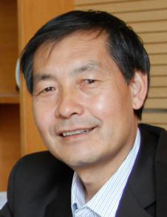
Prof. Dr. Junsheng Shi
Yunnan Normal University, China

Prof. Junsheng Shi is a professor in the School of Physics and Electronic Information, Yunnan Normal University, Kunming, China and also member of China Illuminating Engineering Society-Image Technology Specialized Committee. Since 2001, he has been a Ph.D. in School of Optics and Photonics, Beijing Institute of Technology.
He in charge of Yunnan Province key disciplines "Optical Engineering" and leader for Technology innovation team in color and optical imaging technology of Colleges and universities in Yunnan. He is a member of the Professional Committee of China Optical Technology Optical Society, Chinese Society of Image and Graphics Technical Committee stereoscopic image, foreign journals "Optical Engineering", "Journal of Display Technology" and the present domestic main disciplines journal "Acta Optica Sinica", "Chinese Optics Letters","Acta Photonica Sinica" and other reviewers. In 2004 and 2008, respectively, awards of scientific and technological progress and natural science in Yunnan Province. Three projects of the National Natural Science Fund and two projects of the Yunnan Natural Science Fund have been completed. In past five years, the two major projects in Yunnan Province Department of Education were presided over, more than 50 papers have been published, fifteen invention patents have been applied for, and authorized two. His research interests include color appearance models, the color management systems, characteristics of the human visual system and application for color imaging and digital image processing.

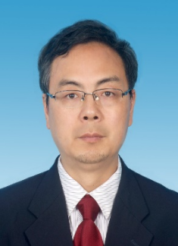
Prof. Yingkai Liu
Yunnan Normal University, China
Yingkai Liu is the dean of the Institute of Physics and Electronic Information, Yunnan Normal University. He obtained his MS degree in condensed matter physics from Yunnan University in 1998 and PhD in condensed matter physics in 2002 from Nanjing University. He then did his postdoctoral research in the Center of Super-Diamond and Advanced Films (COSDAF) at City University of Hong Kong before joining Yunnan Normal University. He visited City University of Hong Kong from Sep. to Jun, 2019 and Rice University from February to December, 2018. His research interests include nanomaterial synthesis & characterization, and Nano device fabrication for photodetectors, gas sensors, environment and biomedical applications. Up to now, he has published 78 articles in the world famous journals such as Advanced Materials, Advanced Optical Materials，Sensors and Actuators B, Applied Physics Letters, and Nanomaterials etc. His papers were cited 1800 times by other people.

Organizing Chair
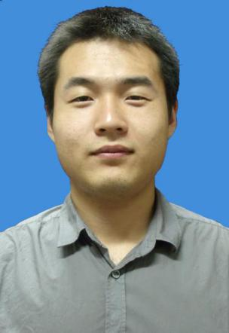
Dr. Yonghang Tai
Yunnan Normal University, China

Prof. Yonghang Tai is a professor in the School of Physics and Electronic Information, Yunnan Normal University, Kunming, China, Color & Image Vision Lab. He got his MSc at Yunnan Normal University, Kunming, and Ph.D. in Opto-Electronic Engineering (OE) at Deakin University, Melbourne, Australia. His main research interests are in 3D HMD design, AM-OLED drive circuit design, and Stereoscopic imaging systems. Prof. Tai had published more than 60 journal and conference papers and has 6 patents. He chairs many high-level research projects, such as the NSFC and the provincial natural science foundations. Prof. Tai was the editor and reviewer of many indexed journals. He was a tutor of MSC and PhD students who successfully defended their works.

International Advisory Chair
- R.Roumiana Kountcheva
1973 M.Sc. in Computer Science, Technical University of Sofia, Bulgaria;
1977 Ph.D. ; Senior Researcher TIE - 1992
Present - Vice president of TK Engineering, Sofia
Main scientific interests: Image processing, Image compression and digital watermarking, Image tensor representation, CNCs, Programmable controllers.
Total number of publications: 176 (30 Journal papers, 18 Book chapters)
Plenary speeches at international scientific conferences and scientific events: 15.
Scientific research projects (PI and Co-PI): 45.
Patents: 5 (2 USA and 3 EU).
Member of Bulgarian Association for Pattern Recognition (member of IAPR).
Member of International Research Institute for Economics and Management (IRIEM), http://www.iriem.org/memberships/Members.aspx
Member of Institute of Data Science and Artificial Intelligence (IDSAI), http://www.idsai.org/memberships/Members.aspx
Honorary Member of the Honorable Editorial Board of the nonprofit peer reviewed open access IJBST Journal Group

Chair Members

  - Technical Program Committee

- KEYNOTE/INVITED SPEAKER

- AUTHOR’S GUIDE
  - Paper Topics
The conference will be held every year to make it an ideal platform for people to share views and experiences in physics, photonics, optoelectronics, optical engineering and related areas. Scholars at home and abroad are welcomed to submit articles and participate in the conference.
The topics of interest for submission include, but are not limited to:
- Image processing
Color management systems
Color appearance models
Digital image processing
3D computer vision
Biomedical optics and imaging
Digital holography and quantitative phase imaging
3D image acquisition and display
VR/AR/MR in surgical simulation
Physic-based rendering
Medial image processing
Systems or devices for optical and digital image processing
Image information management
Holography and display systems
Image analysis

- Applied physics
Experimental mechanics applications
Micro/nano-metrology
Optical wireless
Optical communication networks
Optical fiber communication
Free-space optical communication
Biomedical optics
Advanced biological microscopy
Optical coherence tomography
Minimally invasive optical diagnostics
Optics in biotechnology
Optical-system engineering for medicine

- Photonics
Silicon photonics
Nonlinear optical devices and all-optical signal processing
High performance semiconductor optical amplifiers
Optical sensors and applications
Laser physics and nonlinear optics
Fiber optics and sensing technology
High Resolution optical metrology
Diffractive and freeform optics
Optical methods in experimental
Advanced Optical Measurement Methods
Optical component and system simulation
Optical functional materials and devices

- Optoelectronics
New optoelectronic device materials and processing
Intelligent optoelectronic devices and optical switching
Advanced optoelectronics device fabrication technologies
Photoelectric technology and application
Photoelectric signal processing
Laser materials, fabrication and characterization
White LED and related technologies
Advanced radio-over-fiber devices and related technologies
Slow and fast light devices and related technologies

- Optical Engineering
Optical design and manufacturing
Optical metrology and detection
Laser technology
Optical storage and recording
Optical information processing
Photoelectric display
Optical and optical fiber sensing
Laser material processing and processing
Photoelectric measurement
Optical remote sensing technology

  - Paper Submission
- English is the official language of the conference, automatic translation is not permitted, and all of the papers should be written and presented only in English.

- All of the papers should be submitted in WORD and PDF formats, and all of the papers should be typeset according to the template on the official website, all the accepted paper must present on the conference by oral, video or poster.

- All of the papers submitted to the conference should report original, previously unpublished research results, experimental or theoretical, and the copyrights of the papers should not have been demised to any institution, organization or individual.

- After acceptance, all the final version signed copy right and related materials ,which must be revised and refined according to the reviewers’ and conference committee’s requests, need to sent as the conference secretary/manager’s notification.

Submission Method
Prospective authors are invited to submit their full papers (including all sections, figures, tables and references) via Easy Chair link

  - Paper Review
All submissions to this conference will be sent to at least 2 independent reviewers selected from a group of well-established researchers by the Editor-in-Chief and evaluated based on originality, technical and research content, relevance to conference, contributions, and readability. The full paper submissions will be chosen based on technical merit, interest, applicability, and how well they fit a coherent and balanced technical program.

We will first check plagiarism status of each submitted paper, and there is a hard rule that the similarity rate can not exceed 20%. We take plagiarism case very seriously, which include self-plagiarism of authors' own published papers. Papers with high percentage of plagiarism and self-plagiarism will not be considered. If an author is found to commit an act of plagiarism, the following acts of sanction will be taken:
- Reject the paper submitted or delete the paper from the final publications.
- Report the authors violation to his/her supervisor(s) and affiliated institution(s).
- Report the authors violation to the appropriate overseeing office of academic ethics and research funding agency.
- Reserve the right to publish the authors name(s), the title of the article, the name(s) of the affiliated institution and the details of misconduct, etc. of the plagiarist.
- Each paper should clearly indicate the nature of its technical/scientific contribution, and the problems, domains or environments to which it is applicable. To facilitate the double-blind paper evaluation method, authors are kindly requested to produce and provide the paper WITHOUT any reference to any of the authors, including the authors’ personal details, the acknowledgments section of the paper and any other reference that may disclose the authors’ identity.

  - Paper Registration
Items | Fee
Regular registration | ￥3200/paper
Student registration(first author) | ￥3000/paper
Extra page (charge from page7) | ￥400/page
Escort attendees to the conference | ￥1200/person
For multiple submissions, please contact us.

Note:
- The regular registration fee is 3200 yuan.
- For a full-time student (first author), the registration fee is 3,000 yuan; a valid student identity card is required.
- Each paid registration only covers one paper under the name of corresponding author.
- For sponsors and teams to submit multiple papers, please contact the conference secretary/manager; each author (corresponding author) can submit at most 2 papers.
- If a paper exceeds 6 pages, an extra page fee of 400 yuan/page will be charged starting from page 7.
- The registration outside of China can be paid according the newest currency rate.
- Registration fee covers conference materials, lunches, coffee Breaks and conference kits during the conference.
6. At least one author of each article should attend the conference and present the paper in person or in the form of video or poster.
7. If you are willing to attend the conference and do presentation without publishing your paper, please email us for an application.
8. Please ensure that all registration fees are paid to us through the banking system in strict accordance with the registration form; the invoice information must be carefully checked with the author's financial department.
9. The following items are Not included in the registration:
*Accommodation fee
*Visa application fee
*Transportation fee
* others.

  - Paper Publication

- CONFERENCE PROGRAM
ICPPOE2022 will be held in Kunming of China on August 12-14, 2020. The following information about the schedule is for your reference.
Conference Schedule
November 11 | 09：00-17：00 | Registrations
November 12 | 08：30-09：00 | Opening Ceremony
 | 09：00-12：00 | Keynote Speeches
 | 12：00-14：00 | Lunch
 | 14：00-17：00 | Oral Presentations
 | 17：30-19：00 | Banquet
November 13 | 09：00-17：00 | Oral Presentations

* This is the conference program outline. Actual time arrangement may be a little different according to participant numbers.

  - Conference Venue

Fontaine Blanche Hotel

The hotel, a five-star hotel is located in the Chenggong Campus of Yunnan Normal University, Juxian Street, Chenggong District, Kunming City. It is surrounded by 9 colleges and universities with beautiful environment.

Hotel Address:
No.768 Juxian Street, University Town Chenggong District Kunming 650500 China

Hotel Front Desk Telephone:
0086871-67468888

You can also call the conference affairs group for any consultation.
Tel.: +86 18271938662

Hotel Transportation
- From Kunming Railway Station to Hotel
By Subway: Walk about 500 meters to Kunming Railway Station (Metro Station), take Metro No. 1 →After 13 stops, get off at Lianda Street Station (C exit)→Walk about 174 meters to Lianda Street Bus Station (Choi Yuen South Road)→Take Bus No. Z54, after 2 stops, get off at Juxian Street→Walk about 593 meters to the hotel.
By Taxi: About 28.3 kilometers, cost about 71 RMB or so.

- From Kunmingnan Railway Station to the Hotel
Walk about 302 meters to west square of Kunmingnan Railway Station, take Bus No. K35, after 1 stop and get off at the Juxian Streeet Station→Walk 539 meters to the hotel.
By Taxi: About 4.7 kilometers, cost about 12 RMB or so.

- From Kunming Changshui International Airport to Hotel
By Subway: Walk about 50 meters to the Changshui International Airport-Southern Passenger Station→Take Airport Express Line 4, after 1 stop and get off at Century City→Walk about 339 meters to Erji Road metro station→Take Metro No. 1, after 7 stops, get off at Lianda Street Station (C exit)→Walk about 174 meters to Lianda Street Bus Station (Choi Yuen South Road)→Take Bus No. Z54, after 2 stops, get off at Juxian Street→Walk about 593 meters to the hotel.
By Taxi: About 44.1 kilometers, cost about 113 RMB or so.

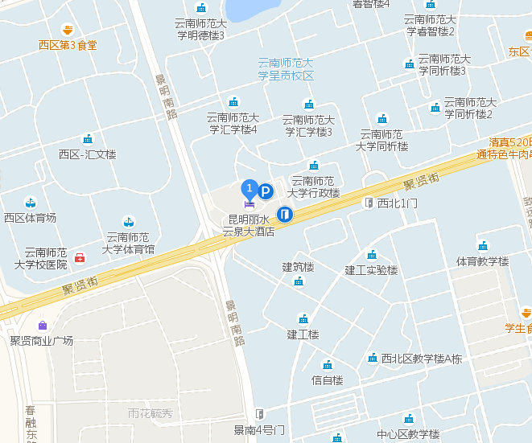

  - Oral Presentation Instruction
1. Timing: a maximum of 15 minutes total, including speaking time and discussion. Please make sure your presentation is well timed. Please keep in mind that the program is full and that the speaker after you would like their allocated time available to them.
2 You can use CD or USB flash drive (memory stick), make sure you scanned viruses in your own computer. Each speaker is required to meet her/his session chair in the corresponding session rooms 10 minutes before the session starts and copy the slide file(PPT or PDF) to the computer.
3 It is suggested that you email a copy of your presentation to your personal inbox as a backup. If for some reason the files can’t be accessed from your flash drive, you will be able to download them to the computer from your email.
4 Please note that each session room will be equipped with a LCD projector, screen, point device, microphone, and a laptop with general presentation software such as Microsoft PowerPoint and Adobe Reader. Please make sure that your files are compatible and readable with our operation system by using commonly used fronts and symbols. If you plan to use your own computer, please try the connection and make sure it works before your presentation.
5 Movies: If your PowerPoint files contain movies please make sure that they are well formatted and connected to the main files.

  - Poster Presentation Instruction
1. Maximum poster size is 60 CM wide by 80 CM high（A1）.
2. Please note that during your poster session, the author should stay by your poster paper to explain and discuss your paper with visiting delegates.

- CONFERENCE HISTORY

7. CONTACT
IRNet International Academic Communication Center aims to establish a worldwide network of researchers and scholars of various disciplines, for providing them supports they need during their initial research time through arranging symposium, seminar and workshops in their disciplines.
We are committed to network among the researchers, scientists, academicians and professionals from Industries.
- Jointly organizing international academic conferences and providing publication services for proceedings.
- Jointly hosting expert seminars to render assistance in the construction of key disciplines.
- Jointly arranging thesis writing lectures to extend guidance on high-quality publications.

We are seeking Technical Program Committee (TPC) and Keynote Speakers for our conferences, if interested to serve ICPPOE in any of these capacities, please send your CV and a short profile to us.

Universities, research institutions, organizations and Think Tanks that are interested and willing to join and partner us as conference co-organizers and sponsors of our conferences, please contact us.

If you have any questions, please feel free to contact our conference secretary.
Conference Secretary: Ms. Yang
Conference Secretary E-mail: ICPPOE@163.com
Tel: 027-87153536
M/P: 18271938662

Conference Secretary WeChat Official Accounts

Important Dates & Deadlines
Final Submission Due: August 1, 2022
Notification of Acceptance: September 25, 2022
Final Version with Copy Right: October 5, 2022
Date of Conference: November 11-13, 2022

Join Us
We are seeking Technical Program Committee (TPC) and Keynote Speakers for our conferences, if interested to serve ICPPOE in any of these capacities, please send your CV and a short profile to us.
Universities, research institutions, organizations and Think Tanks that are interested and willing to join and partner us as conference co-organizers and sponsors of our conferences, please contact us.
Conference Secretary:ICPPOE@163.com
Tel: 027-87153536

Key Review Policy
1.All submitted papers MUST be written in English,automatic translation is not permitted.
2.Any submission must not have been, or will not be published elsewhere or submitted to another conference before the review notification date of this conference.
3.All submissions will be peer-reviewed based on originality, technical quality and presentation,at least 2 independent reviewers review the manuscript.
4.Each paper should be at least 4 pages or longer.
5.To complete the paper plan in advance and expand the scale of the meeting, ICPPOE2022 encourages you to recommend more manuscripts.
6.Article repetition rate cannot be higher than 20%, otherwise it will be rejected directly.

Download
CFP
Invitation
Template Description

